ROYAL UNIVERSITY OF BHUTAN
College of Science and Technology Computing Technologies Department
Bachelor of Engineering in Software Engineering


IDE201 SOFTWARE ENGINEERING CAPSTONE PROJECT

PROJECT PROPOSAL

Students Attendance System (SAS)
“CheckIn” A Credit-Based, Hardware-Free Attendance and Engagement Platform

Group Number | Group 2
Academic Session | AS 2026
Academic Supervisor | Mrs. Dechen Tshomo
External / Industry Supervisor | Mr. Parsu Ram Dhungyel
Date of Submission | September 2, 2026

Group Members

# | Full Name | Student Number | Role in Project | Signature
1 | Dechen Wangmo (L) | 02250349 | Leader
2 | Ugyen Norbu | 02240369 | Member
3 | Damchey Lhendup | 02250347 | Member
4 | Sanskar Gurung | 02250368 | Member
5 | Sanjuck Subba | 02240357 | Member

Declaration and Endorsement
We hereby declare that this proposal is our own original work, that all sources used have been duly acknowledged and cited, and that no part of this document has been submitted for assessment in any other module.

Group Leader | Academic Supervisor
Name: Dechen Wangmo  Signature:  Date: September 2, 2026 | Name: Mr. Parsu Ram Dhungyel  Signature:  Date: September 2, 2026

External Supervisor / Organisation Confirmation

Organisation
Supervisor Name & Designation | Mr. Parshu Ram Dhungyel, HOD/Programme Leader BEIT, Computing Technologies Department
Contact (email / phone) | +975 17 69 63 63, parshuram.cst@rub.edu.bt
Confirmation of implementation plan | Signature: Date: September 2, 2026  Seal:

Project Identification

Reference Number
Project Title | Students Attendance System (SAS) “CheckIn”
Keywords (max 5) | Attendance Management; Geofencing; Web Application; Timetable Management; Student Attendance
Project Status | New
Project Duration | Week 7 to Week 17–19 — approx. 11 weeks
Expected Start Date | September 4, 2026

Organisations Involved

# | Organisation | Type (Industry / Academic / Funding) | Role and Contribution
1 | College of Science and Technology (CST) | Academic | The project is developed for the academic and institutional context of CST. The proposed system is designed to meet the attendance management needs of CST and will be evaluated within the college context.

Abstract
Attendance management is an important part of academic administration at the College of Science and Technology (CST). The current attendance process involves manual recording, which can take time during classes, require additional effort to manage records, and make it difficult to maintain attendance information in one central location. There is therefore a need for a more efficient and organised approach to recording and monitoring student attendance.
This project proposes CheckIn, a web-based Student Attendance System designed for the CST context. The system will allow teachers to create time-limited check-in codes for scheduled classes, while students can record their attendance through the system during the active check-in period. A location-based verification approach will also be explored to support attendance verification. Attendance records will be stored centrally and presented through role-based dashboards, allowing relevant users to view and manage attendance information according to their responsibilities. The system will also include a process for handling absence or relief requests with supporting documents.
The system will be developed using modern web technologies, including a JavaScript-based frontend and backend with a relational database. Research on attendance and student engagement will also be reviewed to explore whether an evidence-based credit or incentive approach could be considered by CST management in the future.
The expected outcome is a functional prototype that demonstrates a more organised, accessible, and efficient approach to student attendance management at CST.

.

Table of Contents

Section | Page No.
Declaration and Endorsement | 2
Project Identification | 3
Abstract | 4
Table of Contents | 5
1. Introduction | 6
1.1 Background | 6
1.2 Problem Statement | 7
1.3 Stakeholders | 7
1.4 Significance and Motivation | 8
2. Literature Review and Related Work | 9
2.1 Review of Existing Literature | 9
2.2 Comparison of Existing Solutions/Studies | 12
2.3 Research Gap | 15
3. Aim, Objectives and Scope | 15
3.1 Aim | 15
3.2 Objectives | 16
3.3 Scope | 17
3.4 Deliverables | 18
4. Methodology and System Design | 18
4.1 Development Methodology | 18
4.2 System Design | 20
4.2.1 User Roles | 21
4.2.2 System Architecture | 23
4.2.3 Database Design | 24
4.2.4 User Interface Design | 25
4.2.5 Testing and Evaluation | 26
5. Technical Implementation Plan | 27
5.1 Technology Stack and Justification | 27
5.2 Source Control and Code Review Workflow | 30
5.3 Resource Requirements | 30
6. Feasibility and Impact | 30
6.1 Target Users and Beneficiaries | 30
6.2 Feasibility Analysis | 31
6.3 Scalability and Commercialization Potential | 32
6.4 Ethical, Legal and Data Considerations | 32
7. Expected Outcomes | 33
8. Project Plan | 34
8.1 Milestones | 34
8.2 Risk Assessment | 36
9. References | 38

Introduction

Background
Attendance is an important part of academic administration as it shows the participation of students in their classes. At CST, attendance for theory and practical classes is currently recorded using paper attendance sheets. Tutors may call the students names or ask students to sign the attendance sheet. After the class, the records are collected and attendance percentages are calculated for academic monitoring and the PBE process.
The paper-based method is simple and familiar, but it has some challenges. Taking attendance manually can use class time, especially when there are many students. It can also allow proxy attendance, where a student records attendance for another student who is absent. Checking and updating the paper records also requires extra manual work. Students also have limited access to check their current attendance status.
These problems show the need for a more centralised attendance system. A digital system can make attendance recording and checking easier and reduce manual work. It can also help reduce proxy attendance by using controlled check-in and location-based verification.
The proposed CheckIn Student Attendance System is a web-based system designed for CST. It will provide controlled student check-in, location verification, centralised attendance records, and different access for students, teachers, and authorised staff. An optional credit tracking feature may also be considered if it is approved by CST management.

.

Problem Statement
At CST, attendance for theory and practical classes is currently recorded using paper attendance sheets. Tutors call students names or ask them to sign the attendance sheet. The records are then collected and attendance percentages are calculated manually. This takes extra time and effort from the tutors.
The paper-based process also makes it difficult to keep attendance records accurate and easy to access. Students can sign for absent classmates, which can cause proxy attendance. Checking and combining attendance records from different class sheets also requires extra manual work. Students have limited access to check their current attendance, while tutors and staff need to collect or calculate the records.
There is also no common process for handling legitimate absences. Students who miss classes due to illness or other valid reasons may need to inform staff through different methods. Staff then have to check the supporting documents and update the attendance records manually.
Therefore, there is a need for a centralised attendance management system that reduces manual work, provides easy access to attendance information, helps prevent proxy attendance, and supports a clear process for submitting and reviewing legitimate absence requests.

Stakeholders

The proposed CheckIn Student Attendance System involves several stakeholders who have different roles and interests in the management of student attendance at CST. The main stakeholders include students, teachers or tutors, the Dean of Academic Affairs (DAA), ICT personnel, and CST management. Understanding their responsibilities and needs is important for defining appropriate system requirements and ensuring that the system supports both day-to-day attendance activities and academic administration.
Stakeholder | Role / Interest | What they need from the system
1. Students | Primary users who record and monitor their own attendance. | A simple way to check in during scheduled classes, view attendance records, receive low-attendance notifications, and submit absence-relief requests with supporting documents.

2.Teachers | Record and monitor attendance for the classes they teach. | A way to manage class attendance sessions, monitor student check-ins, review attendance information, and review flagged or exceptional attendance cases.
3. Dean of Academic Affairs (DAA) | Academic administrator responsible for monitoring attendance and reviewing legitimate absence cases. | Centralised attendance records, monitoring and reporting capabilities, and the ability to review and approve or reject relief requests.
4. System Administrator (ICT Officer) | Supports the technical operation and administration of the system. | User and system administration functions, access control, system maintenance, and monitoring of technical issues.
5. CST Management | Institutional decision-makers who determine whether the system and any proposed attendance policies are appropriate for adoption. | Reliable attendance information and a system that can support institutional attendance procedures. They would also be responsible for considering any optional credit/reward mechanism before adoption.

The identified stakeholder needs provide the basis for defining the functional and non-functional requirements of the CheckIn Student Attendance System. Students require convenient and transparent access to their attendance information, while teachers and the DAA require reliable records and appropriate monitoring and review capabilities. ICT personnel require a system that can be maintained and administered securely, and CST management requires information that can support institutional decision-making. These needs will be considered when designing the system and evaluating its feasibility and potential impact.

1.4 Significance and Motivation
The proposed CheckIn Student Attendance System is significant because it addresses the attendance management problem at CST. The current paper-based process takes class time and requires extra work to calculate and check attendance records. A centralised digital system can reduce this manual work and make attendance records easier to access.
The project also aims to improve the accuracy and reliability of attendance records. Paper attendance can allow proxy attendance and makes it difficult to confirm if a student was present. CheckIn will use controlled check-in during scheduled classes and location-based verification to help reduce proxy attendance. The system will also use role-based access so students, tutors, and authorised staff can access the information they need.
The project also supports the use of digital solutions in education. By replacing the paper-based attendance process with a web-based system, it can improve efficiency, accessibility, transparency, and record management at CST. The system can also be extended for other programmes or institutions in the future if it proves to be effective.
The system can also help students keep track of their attendance status. Tutors and authorised staff can monitor attendance and identify students who may need attention. An optional credit-tracking feature may also be considered if it is approved by CST management and follows the required academic policies.

Literature Review and Related Work

Review of Existing Literature
Student attendance has traditionally been recorded using paper registers, roll calls, and other manual methods. These methods are simple, but they can take class time, cause recording errors, and make attendance records difficult to manage. They can also allow proxy attendance. Because of these problems, many studies have looked at digital attendance systems that can make attendance recording easier and more reliable.

Digital Attendance and Automated Verification
Many studies focus on replacing manual attendance with electronic methods. Kassarnig et al. (2017) studied student attendance using smartphone location and Bluetooth data. Their study showed that digital data can be used to monitor attendance and that regular attendance was related to academic performance.
QR codes are another simple method used for digital attendance. Students can scan a QR code shown by the tutor instead of waiting for their names to be called. This can save time, especially in large classes. However, QR codes alone cannot confirm if the student is actually in the classroom. An absent student could receive the QR code from another student. Mandal et al. (2025) used a dynamic QR code together with a geofenced area to help reduce proxy attendance.

Location-Based and Geofencing Approaches
Location-based attendance systems check if a student's device is within a specific area. Geofencing can be used to create a defined area where students are allowed to check in. Eweoya et al. (2025) developed a web-based university attendance system using geofencing and reported improvements in attendance monitoring and administrative work.
However, location checking also has some limitations. The accuracy can change depending on the device, internet connection, building, and indoor environment. Because of this, location should not always be treated as perfect proof that a student is present. For CheckIn, location verification can be used as an additional check, while unsuccessful location checks can be reviewed by the tutor instead of automatically rejecting the attendance.

Biometric Attendance Systems
Biometric attendance systems use methods such as facial recognition and fingerprint scanning to identify students. These systems can help reduce proxy attendance because they check the identity of the person recording attendance.
However, biometric systems can have problems with accuracy, privacy, and implementation. Facial recognition can be affected by lighting and camera quality. Biometric systems also require the collection and storage of sensitive information. This issue was also observed in two earlier CST capstone projects that used facial recognition for attendance. Both projects reported that the facial recognition check could be bypassed by presenting a photograph of the student instead of the actual student. For a hardware-free capstone project at CST, a web-based system using students' existing devices is more suitable than using biometric systems.

Existing Institutional Learning Platform: CST VLE/Moodle
The College of Science and Technology (CST) already uses a Virtual Learning Environment (VLE) based on Moodle for online learning and other academic activities. Therefore, the proposed attendance system should work alongside the existing VLE instead of replacing it.
Moodle also has an Attendance activity that allows tutors to record attendance and students to record their own attendance. It supports scheduled sessions, attendance status, reports, passwords, and QR codes. However, CheckIn is focused specifically on the attendance needs of CST. It will use timetable-linked sessions, time-limited check-in, location verification, tutor review of flagged cases, student attendance viewing, and an absence request process.
Therefore, the research gap is not that Moodle cannot record attendance. The gap is that CheckIn is designed as a dedicated attendance management system for the specific attendance needs of CST, while the existing VLE continues to be used mainly for learning activities.

Gamification, Rewards and Attendance
Some studies have also looked at using rewards to encourage students to attend classes. Pinter et al. (2020) developed the BeHere attendance system, which used game-like features such as points to encourage regular attendance. Caton and Greenhill (2014) also studied a rewards and penalties approach and found higher attendance and engagement during the study.
Recent studies also show that gamification can affect student behaviour, but the results depend on how the reward system is designed. Elliott et al. (2024) studied a points-based attendance system and found that it was possible to use the system and that it was linked with increased attendance.
For CheckIn, these studies support the idea of using a credit system as an optional feature. However, it should not be treated as a guaranteed solution. Any credit or reward system would need approval from the appropriate CST authority.

Synthesis of Existing Literature
Overall, the literature shows that no single attendance method can solve all attendance problems. Manual systems are simple but take more time and can allow errors and proxy attendance. QR codes make attendance faster but can still be shared with absent students. Biometric systems provide stronger identity checking but have privacy, accuracy, and implementation issues. Location-based systems can help confirm physical presence without special hardware, but their accuracy can be affected by indoor conditions.
Based on the literature, CheckIn will use a combination of methods to improve attendance verification. These include scheduled classes, short-lived check-in codes, and browser-based location verification. Tutor review will also be used when location information is uncertain. The literature also supports considering an optional credit system, depending on CST approval and further evaluation.

2.2 Comparison of Existing Solutions/Studies

Existing Solution / Study | Technology Used | Strengths | Limitations
Manual Paper-Based Attendance at CST | Paper attendance sheets and manual record keeping | Simple to implement; requires no technical infrastructure; familiar to tutors and students | Time-consuming; records can be misplaced or damaged; attendance calculations and consolidation require manual effort; vulnerable to proxy attendance
CST VLE (Moodle) | Moodle-based Virtual Learning Environment | Already used at CST; supports course materials, assignments and other learning activities; Moodle can also support attendance activities | Primarily designed as a learning management platform; attendance workflows depend on how individual courses configure Moodle; does not specifically provide the complete attendance workflow proposed for CheckIn
CST Attendance Management System (2022) | Mobile app and web dashboard; QR code check-in with facial recognition verification (React Native/Expo, React.js, Node.js/Express.js, MongoDB, OpenCV) | Fast QR-based check-in combined with an identity check before scanning; provided both mobile and web access | Check-in window was limited; still had a high chance of proxy attendance; students could only view their own attendance record; facial recognition accuracy issues
CST Attendance Management System using Facial Recognition and Geofencing (2025) | Mobile app and web dashboard; facial recognition for login and attendance, GPS-based geofencing (React Native/Expo, Next.js, ASP.NET Core, PostgreSQL, TensorFlow/FaceNet, Haversine formula) | Combined two verification methods (facial recognition and location) to reduce proxy attendance; used the Haversine formula for distance calculation, similar to CheckIn | Facial recognition could be bypassed using a photograph; GPS-based location verification was not usable on laptop devices, limiting the system to mobile phones
QR-Code Attendance – Applied Science Private University | QR codes and mobile/web-based attendance | Reduces manual recording; quick for students to use; provides digital attendance records | A shared QR code may be susceptible to proxy attendance if additional verification is not used
BeHere – Subotica Tech | Mobile/location-based attendance with gamification | Combines attendance tracking with engagement-oriented features; reduces dependence on paper-based recording | Requires students to use a compatible digital platform; location-dependent approaches can be affected by positioning accuracy and device permissions
Rewards and Penalties – Kingston University | Attendance monitoring with reward/penalty mechanisms | Demonstrates how incentives can be used to encourage attendance and participation | Reward or penalty policies depend on institutional rules; the approach does not by itself provide strong verification of physical attendance
Location-Based Attendance – Kassarnig et al. (2017) | Mobile location information / location-based verification | Uses physical location as an additional indicator of student presence; reduces reliance on manual attendance | Location accuracy can vary depending on device and environment; location alone does not necessarily confirm that the correct student is attending
Electronic Attendance Tracking – Constantine the Philosopher University | Electronic/digital attendance management | Reduces paper-based administration and provides more accessible attendance records | Effectiveness depends on the specific verification and implementation methods used; electronic recording alone may not prevent proxy attendance
Proposed CheckIn Student Attendance System | Web application, time-limited check-in codes, timetable integration, browser-based location verification, role-based access | Combines controlled check-in, location-based verification, attendance monitoring, student visibility and absence-relief workflow in one purpose-built system | Requires internet/device access and appropriate institutional approval; location verification may have accuracy limitations and flagged cases require tutor review

Research Gap
Existing attendance systems show that digital technology can reduce the work needed for manual attendance recording. QR code systems can make check-in faster, while location-based systems can help confirm a student’s presence. Moodle can also support digital attendance within an existing learning environment.
However, these systems do not fully address the specific attendance needs of CST. There is a need for a system that provides timetable-linked check-in, location verification, clear attendance information for students and tutors, review of invalid check-ins, and a process for legitimate absence requests. Incentive-based features may also help improve attendance, but they depend on institutional policies.
This gap is also reflected in two earlier CST capstone projects that attempted similar attendance solutions: a 2022 system that combined QR codes with facial recognition, and a 2025 system that combined facial recognition with GPS-based geofencing. Both systems reported practical limitations, including a continued risk of proxy attendance, while the 2025 system reported that facial recognition could be bypassed using a photograph and that GPS-based location verification was not usable on laptop devices. CheckIn responds to these specific problems by using a time-limited check-in code together with browser-based location verification and tutor review of flagged cases, without relying on biometric data or device-dependent GPS tracking.
Therefore, the research gap is the lack of a single, hardware-free attendance system that combines these requirements for the CST context. This gap forms the basis for the objectives of the proposed CheckIn Student Attendance System.

- Aim, Objectives and Scope

Aim

To develop a secure and digital student attendance system for the College of Science and Technology (CST) that improves the accuracy, transparency, and efficiency of attendance management through controlled digital check-in, location-based verification, attendance monitoring, and structured absence management.

Objectives

# | Objective | Verification / Success Measure
01 | To design and implement a role-based authentication and access-control system for students, teachers, DAA staff, and administrators. | Successful login and access-control tests will demonstrate that each user role can authenticate and access only the functions and information permitted for that role.
02 | To develop and integrate a timetable-linked attendance check-in system using time-limited class codes and location-based geofencing. | Tests conducted before, during, and after scheduled classes, and from different locations, will verify that valid check-ins are accepted while invalid or out-of-range attempts are rejected or flagged for review.
03 | To develop an attendance and credit management system that records attendance and updates student credit balances according to configured attendance and participation rules. | System testing will verify that attendance activities correctly update attendance records and that corresponding credit changes are accurately reflected in the database and student dashboard.
04 | To develop a digital absence and relief-request workflow that allows students to submit supporting documents for review by authorised staff. | A complete submission, review, approval/rejection, and record-update workflow will be tested to verify that requests reach the correct reviewer and approved decisions correctly update the student's attendance record.update correctly.
05 | To develop real-time attendance monitoring and low-attendance notification features for students and teachers. | A live demonstration and system testing will verify that attendance updates appear on the teacher dashboard and that an automatic email alert is generated when a student's attendance falls below the configured threshold.

3.3. Scope In scope:
The project focuses on developing a secure and digital student attendance system for CST. The following features are included in the project:
- Secure code-based self-check-in: Students can record their attendance using a class-specific code provided by the instructor.
- Time-limited attendance code: The attendance code will only work during the assigned class period.
- Geofencing/location verification: The system will check the student's location to confirm they are within the allowed attendance area.
- Digital attendance records: Attendance information will be stored digitally for easier access and management.
- Role-based dashboards: Students, instructors, and management users will have different access based on their roles.
- Attendance history and monitoring: The system will store attendance history and allow users to monitor attendance status.
- Credit management for recovering attendance shortage: The system will support credit-based activities to help students recover attendance shortages. The specific credit policy will depend on approval from CST management.

Out of scope:
The following features are not included in the current project and may be considered for future development:
- Automatic selection for competitions, exchange programmes, and scholarships: The system will not automatically select students for these opportunities. Attendance data may be used for future decisions, but the final selection will depend on CST criteria and management decisions.
- Advanced credit policies with college management: The project will demonstrate the proposed credit-management concept, but official credit policies will be decided by CST management.

Deliverables

The following deliverables will be produced and submitted as part of the project:
- Working CheckIn web application: A functional web-based Student Attendance System for students, teachers, DAA staff, and administrators.
- Source code repository: A private GitHub repository containing the project source code and development work.
- Database design documentation: Database design documents, including the Entity Relationship Diagram (ERD), showing the main entities and their relationships.
- Figma interface designs: Figma designs and prototypes showing the main interfaces and user flows.
- Test report: A report covering functional testing, integration testing, role-based access testing, usability testing, and geofencing testing.
- User guide: A simple guide explaining how students, teachers, DAA staff, and administrators can use the system.
- Deployed system: A deployed version of the CheckIn web application for demonstration and testing.
- Final project report and presentation: The completed IDE201 project report and presentation covering the project, system design, development, testing, and results.

Methodology and System Design

Development Methodology
The development of CheckIn will follow the process shown in Figure 4.1. Work begins once a team member logs in and accesses the project system, after which the relevant stage of the project is selected: Identify & Plan, Design, Develop & Integrate, Test, or Deploy.
In the Identify & Plan stage, the team gathers requirements, identifies problems, and records the stakeholders involved, namely students, instructors, and administrators. The findings are stored as project records, and the requirements are confirmed before the team moves to the next stage.
In the Design stage, the team works on the system architecture, entity relationship diagram (ERD), user interface (UI/UX), and overall system workflow. These design files are stored, and the design is reviewed and approved before development begins.
In the Develop & Integrate stage, the main features of CheckIn are developed and integrated. This includes the self-check-in process, geofencing, attendance tracking, and credit system. The source code and database are maintained throughout development, and this stage is considered complete once the planned features have been integrated.
In the Test stage, the team carries out functional, integration, and usability testing. The test results are recorded, and the system is validated before it is prepared for deployment.
In the Deploy stage, the system is implemented and evaluated before being deployed to the CST environment. Once deployment is completed, the system is considered live and operational.
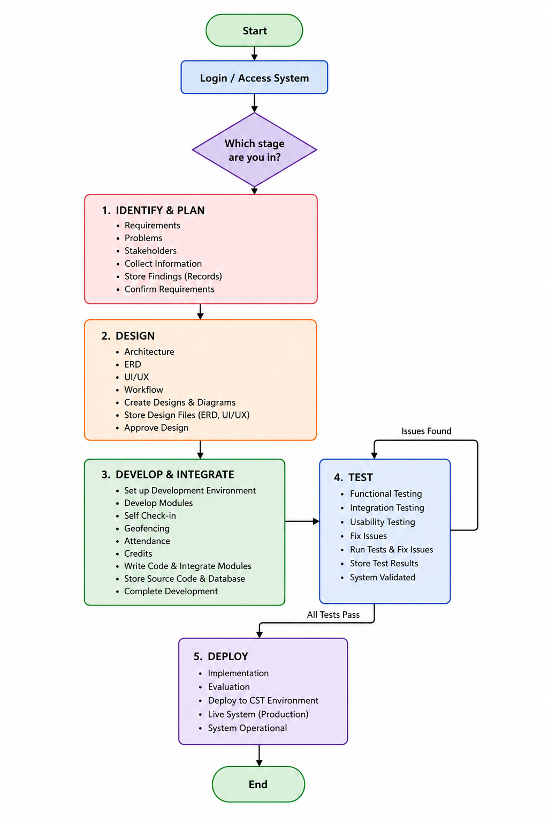

Figure 4.1. Development process flow for the CheckIn system.
This process allows the team to move through each stage of the project in a clear order, from identifying requirements through to deployment. The outputs of each stage, such as requirement records, design files, source code, and test results, are saved before the team moves to the next stage. Testing is carried out as a separate stage before deployment so that problems can be identified and corrected before the system is finalised.

System Design

CheckIn will be developed as a web-based client-server application with three main layers: presentation, application and business logic, and data. The presentation layer will provide the interface for students, instructors, and administrators. The application layer will handle functions such as login, attendance check-in, location verification, credit management, and other system rules. The data layer will store the information needed by the system.
The main attendance process will use a time-limited attendance code and device location verification. An instructor will generate a code for a class session. A student will enter the code while the attendance session is open. The system will check if the code is valid and if the student's device is within the allowed location area of the classroom.
When both checks are successful, the attendance will be stored as a normal check-in. If the code is valid but the location check fails, the check-in will be flagged for the instructor to review instead of being rejected automatically. This gives an extra check against proxy attendance while allowing staff to review cases where the location may not be accurate.
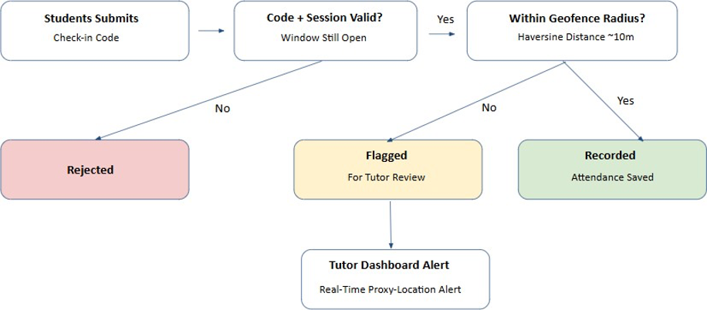
Figure 4.2. Overall workflow of the CheckIn attendance system.
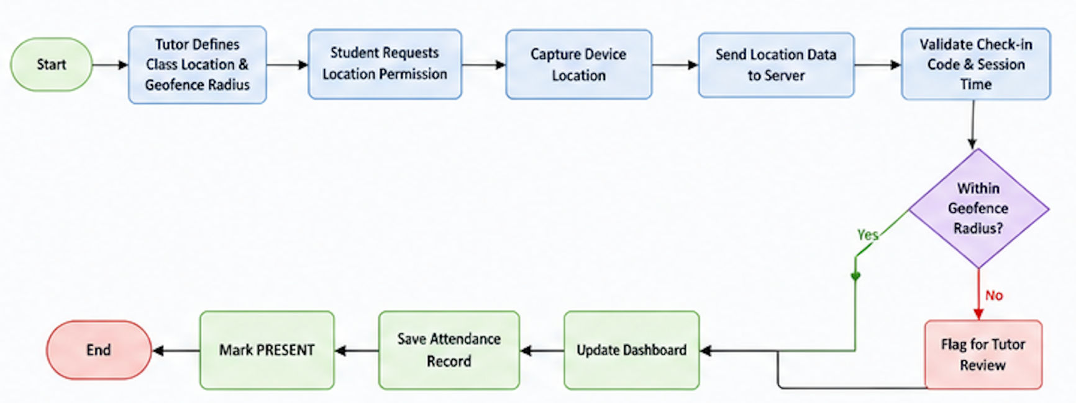
Figure 4.3. Geofenced check-in process using a time-limited code and device location verification.
The system will also provide different dashboards based on the user's role. Students can view their attendance and credit information, while instructors can manage class attendance. Administrators can manage users and system settings. This role-based structure helps make sure users only access the functions related to their responsibilities.

User Roles

The CheckIn system will provide different functions for each user role. The main roles are Student, Instructor/Tutor, and DAA/System Administrator.

Student
Students will use the system to:
- Log in and log out securely.
- Check in to a class using the time-limited attendance code.
- Provide device location for location verification.
- View attendance percentage and attendance history.
- View credit balance and related information.
- Submit relief requests for genuine absences with supporting documents.
- View notifications and attendance alerts.

Tutor
Instructors or tutors will use the system to:
- Log in and log out securely.
- Generate a time-limited attendance code for each class session.
- Monitor attendance during a live class.
- View students whose check-ins are flagged for verification.
- Verify attendance cases when needed.
- Adjust student credits when authorised.
- Monitor attendance information for their classes.

DAA/System Administrator
The DAA/System Administrator will be responsible for higher-level system management. Their functions will include:
- Manage user accounts and access permissions.
- Manage attendance and credit settings.
- Review escalated relief requests when needed.
- Monitor system status and attendance reports.
- Support system security and proper management.
The separation of these roles helps prevent users from accessing functions that are not related to their responsibilities.
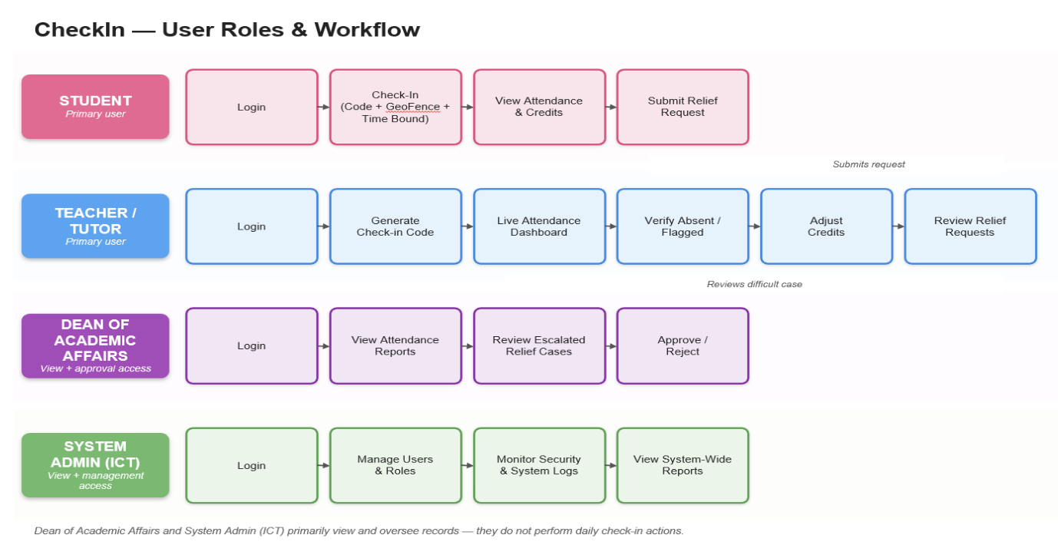
Figure 4.4. User roles and their main functions in the CheckIn system.

System Architecture

CheckIn will follow a three-tier architecture consisting of the presentation layer, application/business logic layer, and data layer.

Presentation Layer
The presentation layer will provide the web interface where students, instructors, and administrators use the system. It will contain the dashboards and functions needed for each user role.
For students, the interface will provide login, attendance check-in, attendance history, credit information, relief requests, and notifications. For instructors, it will provide attendance code generation, live attendance monitoring, flagged check-in verification, and credit management. Administrators will have functions for managing users, policies, and reports.

Application and Business Logic Layer
The application layer will process requests from the web interface and apply the system rules. It will handle login, attendance code validation, attendance recording, credit updates, relief requests, and notifications.
For attendance check-in, the backend will perform two main checks:
- It will verify that the attendance code is valid and that the class session is still within its allowed check-in period.
- It will verify that the student's current device coordinates are within the configured distance from the registered classroom location.
The student's coordinates will be obtained using the browser's Geolocation API. The backend will use the Haversine formula to calculate the distance between the student's location and the registered classroom location.
A check-in that passes both checks will be recorded normally. If the code is valid but the location check fails, the check-in will be flagged for instructor review. This helps identify possible proxy attendance without automatically penalising students when the location reading is not accurate.

Data Layer
The data layer will use a relational database to store users, class sessions, attendance records, credit transactions, relief requests, and notifications. The database will provide one central source of attendance information so authorised users can access updated and consistent records.

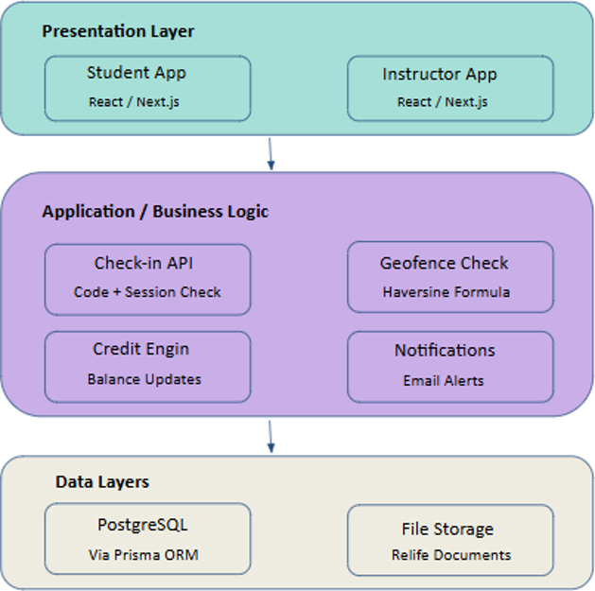

Figure 4.5. Three-tier architecture of the CheckIn system.

Database Design

CheckIn will use a relational database to store and manage the information needed by the system. A relational structure is suitable because the system has different types of related information, such as users, class sessions, attendance records, credits, and relief requests.
The main entities planned for the database are:
- User: Stores common account and login information.
- Student: Stores information about student users.
- Instructor/Tutor: Stores information about instructors and tutors.
- Administrator/DAA: Stores information about administrative users.
- Class/Module: Stores module and class information.
- Timetable Session: Stores scheduled class session information.
- Check-in Code: Stores codes generated for attendance sessions and their valid time periods.
- Attendance Record: Stores student attendance information for each session.
- Credit Transaction: Records changes made to student attendance credits.
- Relief Request: Stores requests submitted by students for genuine absences.
- Supporting Document: Stores information about documents submitted with relief requests.
- Notification: Stores attendance and system notifications sent to users.
These relationships will allow the system to connect students with their classes, sessions, attendance records, credit transactions, and relief requests.
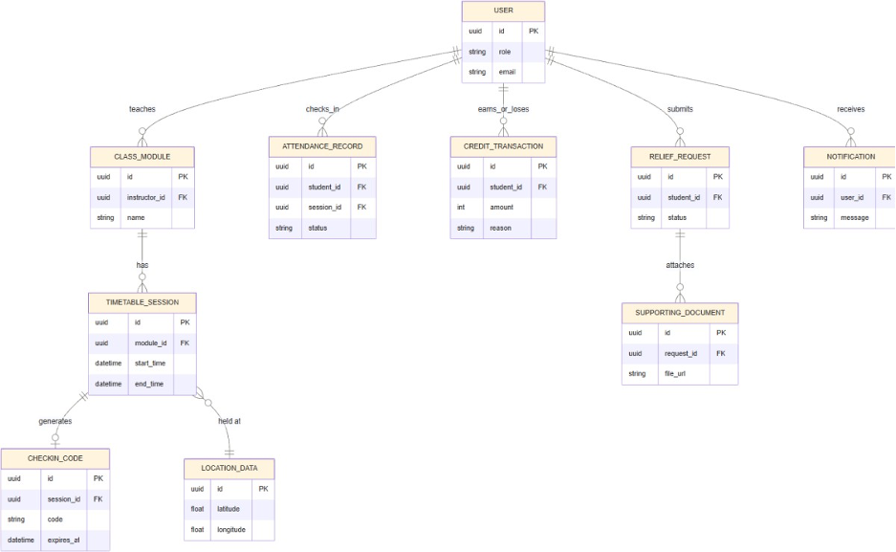
Figure 4.6. Entity Relationship Diagram for the CheckIn database.
The database design will be reviewed during development. Relationships and data requirements can be changed if problems are found during implementation and testing.

User Interface Design

The CheckIn user interfaces will first be designed in Figma before development. The designs will focus on making a simple and consistent interface for each user role.
The main interfaces will include a login page, student dashboard, instructor dashboard, and DAA/administrator dashboard.
The student dashboard will allow students to check in to classes, view their attendance percentage and history, view credit information, submit relief requests, and view notifications.
The instructor dashboard will allow instructors to generate attendance codes, monitor live attendance, view flagged check-ins, verify attendance cases, and manage credits when needed.
The DAA/administrator dashboard will provide functions for managing users and system settings, monitoring attendance information, and viewing reports.
The interface will be responsive so students and instructors can use the web application on commonly available devices without needing dedicated attendance hardware.

Testing and Evaluation

Testing will be done throughout development and after each major module is added. The purpose is to find errors early and make sure the system works correctly for its users.
The following testing activities will be carried out:

Functional Testing
Functional testing will check if individual features work according to their requirements. This will include login, attendance code generation, check-in, attendance records, credit updates, relief requests, notifications, and dashboard functions.

Integration Testing
Integration testing will check if different parts of the system work correctly together. For example, the team will check if a successful check-in updates the attendance record and if the attendance change appears on the correct dashboard.

Role-Based Access Testing
Role-based access testing will check that students, instructors, and administrators can only use the functions allowed for their roles.

Usability Testing
Usability testing will check if users can complete common tasks without getting confused. This will include checking in to a class, viewing attendance information, and submitting a relief request.

Geofencing and Location Verification Testing
Location verification testing will check how the system works at different distances from the registered classroom location. The team will test when the device is inside the allowed area and when it is outside the boundary. Testing will also be done on a small number of devices to check differences in location readings.

System Testing
System testing will check the complete application after the main parts have been connected. It will check if the overall system works as intended and if the completed features meet the project objectives.
The testing results will be recorded in a test report. Problems found during testing will be documented and fixed where possible before the final system demonstration. The report includes functional, integration, role-based access, usability, geofencing, and system testing as the main testing areas.

Technical Implementation Plan

Technology Stack and Justification

Layer | Technology Selected | Justification / Alternatives Considered
Frontend | React / Next.js with Tailwind CSS | React uses reusable components, which is useful for the different dashboards for students, instructors, and administrators. Tailwind CSS helps the team create a responsive and consistent design. Plain HTML, CSS, and JavaScript were also considered, but they would need more code for each dashboard.
Backend | Node.js with Express.js | Node.js and Express.js will be used to create APIs for login, check-in, credits, relief requests, and notifications. Using JavaScript for both frontend and backend means the team does not need to switch between different programming languages.languages.

Database | PostgreSQL with Prisma ORM | The system has many related data, such as users, sessions, attendance records, credit transactions, and relief requests. PostgreSQL is suitable for storing this related data. Prisma makes it easier to work with the database and manage database changes during development.changes during development.
File Storage | Cloud storage such as Supabase Storage | Relief documents will be stored separately from the main database. This keeps large files out of the database and allows the team to control access to these documents separately.
Geolocation | Browser Geolocation API (frontend) + Haversine Formula (backend, Node/Express) | It does not need dedicated hardware or a paid service and works with the existing web stack. This is suitable for the project's hardware-free approach. It will be used for the geofencing check described in Section 4.2.2.geofencing check described in Section 4.2.2.
Hosting /  Deployment | Vercel for the frontend and a low-cost cloud service such as Render for the backend and database | These services can connect directly to a Git repository and make deployment easier. This is suitable for a student team because they do not need to manage their own servers or complex infrastructure.complex infrastructure.
Testing Tools | Postman / Thunder Client for API testing and browser testing for the UI | These tools allow the team to test each API separately, such as login, check-in, and credit changes, before connecting the APIs to the frontend. Browser testing will also be used to check that the user interface works correctly.check that the user interface works correctly.

Source Control and Code Review Workflow

The source code will be stored in a private GitHub repository. All five team members will have access to the repository. The supervisor can also be given access when needed.
The team will use a feature branch workflow. The main branch will contain stable and tested code. Each feature, such as the check-in module, credit module, relief workflow, dashboards, and notifications, will be developed in its own feature branch.
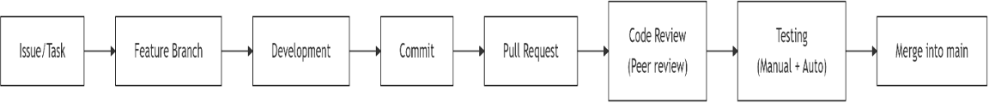
Proposed workflow:
The workflow will follow these steps:
- Issue / Task: A task or feature is identified.
- Feature Branch: A separate branch is created for the task.
- Development: The feature is developed and tested.
- Commit: Changes are committed using clear commit messages.
- Pull Request: The completed feature is submitted for review.
- Code Review (Peer Review): At least one other team member reviews the code.
- Testing (Manual + Auto): The feature is tested before merging.
- Merge into main: After the review and testing are completed, the feature is merged into the main branch.
The team will use clear and simple commit messages. For example:
feat: add check-in code generation
fix: correct credit balance calculation
test: add relief workflow API tests
docs: update ERD
The code review will check if the feature works correctly, the code is easy to understand, the system is secure, and the required tests are included. This workflow will also support the six fortnightly code reviews required by the module. GitHub Actions will be used where possible to automatically run basic build and test checks when a pull request is created.

Resource Requirements

Item / Specification | Quantity | Est. Unit Cost | Justification
Development laptops | 5 | Existing / N/A | Required by team members for coding, testing, and documentation.
Internet connection | 5 | Existing / N/A | Required for GitHub, cloud services, API testing, and deployment.
GitHub repository | 1 | Free tier | Used to store the source code, manage changes, create pull requests, and review code.
Figma | 5 users | Free plan | Used for designing the user interface and creating prototypes.
Cloud hosting (Vercel / Render) | 1 project | Free / low-cost student tier | Used to deploy the frontend and backend for testing and demonstration.
PostgreSQL database instance | 1 project | Free / low-cost student tier | Used to store important system data such as users, attendance, credits, and relief records.
Postman / Thunder Client | 5 users | Free plan | Used to test API endpoints before connecting them to the frontend.

Feasibility and Impact

Target Users and Beneficiaries

Target Users
- CST Students: Use CheckIn to record attendance during scheduled classes using the provided attendance code, verify their location during check-in, and view their attendance history and credit status.
- Teachers/Tutors: Use the system to create and manage time-limited attendance sessions, monitor student check-ins, view attendance records, and review flagged attendance cases.
- Dean of Academic Affairs (DAA): Use the system to access centralised attendance information and review legitimate absence or relief requests where required.
- System Administrator (ICT Officer): Manage user accounts, access permissions, and system administration to support the secure and reliable operation of CheckIn.

Beneficiaries
- Students: Benefit from a faster and more transparent attendance process, easier access to their attendance information, and reduced uncertainty about their attendance status.
- Teachers/Tutors: Benefit from reduced manual attendance-recording work and easier monitoring and management of attendance records.
- Dean of Academic Affairs: Benefit from centralised attendance information and a more organised process for monitoring attendance and handling legitimate absence cases.
- CST Management: Benefit from more accessible and organised attendance information that can support institutional decision-making and consideration of proposed attendance or credit-management approaches.

Feasibility Analysis

Technical Feasibility
The proposed system is technically feasible using technologies that the team is familiar with or can develop skills in through their coursework. The planned technologies include React/Next.js for the frontend, Node.js/Express for the backend, and PostgreSQL for database management. The attendance verification process will use time-limited check-in codes together with browser-based location verification and server-side distance calculation. The system does not require dedicated hardware or machine learning. The main technical challenge will be integrating the authentication, timetable-linked check-in, location verification, attendance, credit, relief-request, notification, and dashboard modules within the available development period. Location accuracy and device permissions will also need to be considered during testing.

Operational Feasibility
CheckIn is designed to fit within the existing attendance process at CST with minimal changes to the responsibilities of staff. Teachers will continue to control attendance sessions and review attendance cases, while students will use their own devices to check in during scheduled classes. Attendance information will be recorded digitally and made available through role-based access. This can reduce manual recording and make attendance information easier for students, teachers, and authorised staff to access and monitor. Therefore, the proposed system can be introduced without requiring major changes to the existing attendance responsibilities or workflow.

Economic Feasibility
The development of the capstone prototype is economically feasible because the team already has access to the required laptops and internet connections. The proposed development and collaboration tools, including GitHub and Figma, provide free plans, while cloud hosting and database services can be used through free or low-cost student tiers. Since the system is hardware-free, no dedicated attendance devices are required for the prototype. If the system were later adopted across CST, additional costs could arise from hosting, database storage, email services, and ongoing system maintenance. However, the expected cost of developing and demonstrating the capstone prototype is low.

Scalability and Commercialization Potential

Scalability
CheckIn is designed as a web-based and hardware-free system, which provides potential for expansion beyond the capstone prototype. The system can be scaled to support a larger number of students, classes, attendance records, and authorised users while maintaining the same core attendance workflow. Its role-based access structure can also support different user groups as the system grows. If the prototype proves effective, the system could potentially be adapted for use across other programmes or educational institutions with appropriate changes to their attendance requirements and policies.

Commercialization Potential
CheckIn has potential for institutional use as a digital attendance management solution for educational organisations that currently rely on manual attendance processes. A future deployment could involve customisation of the system to meet the attendance policies, user requirements, and technical infrastructure of an institution. However, commercialization or institutional adoption is not part of the current capstone project and would require further evaluation, testing, institutional approval, maintenance planning, and consideration of deployment costs. The current project therefore focuses on demonstrating a functional prototype rather than establishing a commercial product.

6.4 Ethical, Legal and Data Considerations
CheckIn will handle personal and academic information, including student attendance records, credit records, and supporting documents submitted through the absence or relief request process. As this information is private, access will be restricted according to user roles and responsibilities. Passwords will not be stored as plain text, and uploaded supporting documents will not be publicly accessible.
The system will also use device location information during the attendance check-in process. The student's device coordinates will be used only at the time of check-in to calculate the distance from the permitted attendance location. CheckIn will not continuously track students outside the attendance check-in process. Location information will be retained only as part of the attendance record where it is required to support the verification process.
From an ethical perspective, the system should use student information only for legitimate attendance-related purposes and should limit access to authorised users. Location-based verification may also be affected by device accuracy, internet connectivity, and indoor environmental conditions. Therefore, location verification should be treated as an additional attendance check rather than as an infallible determination of attendance. Cases where location verification is uncertain can be reviewed by the appropriate teacher or authorised staff.
The project will take relevant Bhutanese data and information-management requirements into consideration, including the Information, Communications and Media Act 2018 and the Data Management Guide 2023. Role-based access and controlled handling of personal information will be used to support responsible management of student data.
Biometric verification, such as fingerprint or facial recognition, is not included in the current project. If such technologies were considered in a future version, additional privacy, security, consent, and institutional considerations would need to be evaluated before implementation.

Expected Outcomes

At the end of the project, a functional web-based CheckIn Student Attendance System will be developed as a prototype for the College of Science and Technology (CST). The expected outcomes are aligned with the five project objectives and will be demonstrated through functional system testing and a final working demonstration.

Objective | Expected Outcome | Demonstration / Evidence
O1 | A working role-based authentication and access-control system for students, teachers, DAA staff, and administrators, with each role having access only to its permitted functions and information. | Demonstrate successful login for each user role and verify that restricted functions and information cannot be accessed by unauthorised roles.
O2 | A timetable-linked attendance check-in system that uses time-limited class codes together with browser-based location verification to validate attendance during scheduled classes. | Create an active class session and demonstrate a valid check-in. Test an expired or invalid code and an out-of-range location to show that the system rejects or flags the attempt according to the defined verification rules.

O3 | An attendance and credit management module that records attendance and updates student credit balances according to the configured attendance and participation rules. | Demonstrate attendance being recorded correctly and show corresponding credit changes in the database and student dashboard.student's dashboard.
O4 | A digital absence and relief request process that allows students to submit requests with supporting documents and enables authorised staff to review and process them. | Submit a relief request with a supporting document as a student, then demonstrate the review process using an authorised staff account and verify the resulting attendance update.
O5 | Role-based attendance dashboards and monitoring features that provide relevant users with attendance information and notifications for low attendance where configured. | Demonstrate attendance information on the appropriate dashboard and show that a low-attendance notification is generated for a sample student when the defined condition is reached.alert.
The completed system will be demonstrated as a working prototype during the final presentation, showing the main attendance workflow from class-session creation and student check-in to attendance recording, monitoring, and related credit or absence management processes.

Project Plan

Milestones

# | Milestone / Deliverable | Target Week | Responsible Member(s)
M1 | Project requirements are collected and validated. The literature review and initial Figma wireframes are also started. | Week 7–8 | All members

M2 | The database design (ERD) and system architecture are completed. The project proposal is reviewed and presented to the supervisor.presented to the supervisor. | Week 8-9 | All members; Design & Database – Ugyen Norbu (Ugyen Norbu)
M3 | User authentication and role-based access control are implemented. Code Reviews 1 and 2 are completed. | Week 9–10 | Damchey Lhendup (Frontend); Dechen Wangmo (Backend)
M4 | The timetable-linked attendance check-in module and browser-based location verification are developed and integrated. Code Reviews 3 and 4 are completed.Reviews 3 and 4 completed. | Week 11–12 | All members
M5 | The credit management module is developed and integrated with attendance records. Integration testing is carried out to verify attendance and credit updates. | Week 13-14 | Damchey Lhendup, Sanskar Gurung; Sanjuck Subba for testing
M6 | The digital relief-request workflow, attendance dashboards, and low-attendance notifications are completed. Deployment testing is carried out and Code Review 5 is completed.Review 5 is completed. | Week 15–16 | All members
M7 | Final system testing, bug fixing, documentation, deployment, and presentation preparation are completed. Code Review 6 is completed. | Week 17-19 | All members

8.2. Risk Assessment
The main risks for the CheckIn project are related to team coordination, technical implementation, time constraints, and the availability of team members. Since the project has a limited development period, these risks will be monitored throughout development and managed through regular communication, task tracking, code reviews, testing, and prioritisation of the core system features.
Risk | Description | Likelihood (1–5) | Mitigation Strategy | Contingency Plan
Team Dynamics | Unequal distribution of work or poor communication may delay tasks and affect the quality of the project. | 4 | Use a shared task tracker and hold regular team discussions to monitor progress, responsibilities, and pending tasks. | Reassign urgent tasks among team members. If the issue continues, discuss it with the supervisor for guidance.
Technical Infrastructure | Laptop failure, loss or corruption of project files, or problems with the development environment may interrupt development. | 3 | Use cloud-based version control and storage, maintain regular backups, and ensure that project work is pushed to the shared repository regularly. | Restore the latest available version from the repository or backup and continue development using another available device.
Time Management | Final integration, testing, documentation, and presentation preparation may take longer than expected and create pressure near the submission deadline. | 3 | Follow the project milestones, set internal deadlines before official deadlines, and monitor progress during each development cycle. | Prioritise core features such as authentication, attendance check-in, location verification, and credit management before completing lower-priority features.
Health and Burnout | Illness, emergencies, or excessive workload may temporarily reduce a team member's availability and affect assigned tasks. | 3 | Ensure that more than one team member understands each major module and distribute workload according to availability. | Temporarily reassign the affected member's tasks to other team members and adjust the development schedule where necessary.

Risk Summary:

Risk Area | Low | Medium | High
Technical risk |  | ☑
Schedule / timing risk |  | ☑
Resource and budget risk | ☑
External dependency risk |  | ☑

- References

Caton, H., & Greenhill, D. (2014). Rewards and penalties: A gamification approach for increasing attendance and engagement in an undergraduate computing module. International Journal of Game-Based Learning, 4(3), 1–12. https://doi.org/10.4018/IJGBL.201407010
CST Capstone Project. (2022). Attendance management system [Unpublished capstone project]. College of Science and Technology, Royal University of Bhutan.
CST Capstone Project. (2025). CST attendance management system using facial recognition and geofencing [Unpublished capstone project]. College of Science and Technology, Royal University of Bhutan.
Elliott, B. P., Glendening, J., Venkatesh, S., Ahmad, A., Prister, J., & Burton, K. M. (2024). The House Cup: Using longitudinal gamification to improve didactic attendance. Journal of Medical Education and Curricular Development, 11, 1–9. https://doi.org/10.1177/23821205231225922
Eweoya, I., Adeniyi, O. J., Awoniyi, A. O., Mgbeahuruike, E., Adewuyi, J. O., Adigun, T. O., & Mensah, Y. A. (2025). Design and implementation of a university attendance management system using geo-fencing. Asian Journal of Computer Science and Technology, 14(1), 28–46. https://doi.org/10.70112/ajcst-2025.14.1.4323
Government Technology Agency. (2023). Data management guide 2023. Royal Government of Bhutan.
Kassarnig, V., Bjerre-Nielsen, A., Mones, E., Lehmann, S., & Lassen, D. D. (2017). Class attendance, peer similarity, and academic performance in a large field study. PLOS ONE, 12(11), e0187078. https://doi.org/10.1371/journal.pone.0187078
Mandal, A., Saha, S., Panda, S., Pal, P., & Gupta, S. (2025). Geolocation-based QR code attendance system for universities to mitigate proxy attendance. Swami Vivekananda University Press. https://doi.org/10.65525/SVUP.9788199651517.2026.140-151
MoodleDocs. (n.d.). Attendance activity. Moodle. https://docs.moodle.org/501/en/Attendance_activity
Parliament of the Kingdom of Bhutan. (2018). Information, Communications and Media Act of Bhutan 2018.
Pinter, R., Čisar, S. M., Balogh, Z., & Manojlović, H. (2020). Enhancing higher education student class attendance through gamification. Acta Polytechnica Hungarica, 17(2), 13–33. https://doi.org/10.12700/APH.17.2.2020.2.2

